**INDEX**

|  |  |
| --- | --- |
| **Sr.no.** | **Practical** |
| **1** | **A]Design a simple machine learning model to train the training instances and test the**  **same.** |
|  | **B]Implement and demonstrate the FIND-S algorithm for finding the most specific hypothesis based on a given set of training data samples. Read the training data from a .CSV file** |
| **2** | **A]Perform Data Loading, Feature selection (Principal Component analysis) and Feature Scoring and Ranking.** |
|  | **B] For a given set of training data examples stored in a .CSV file, implement and demonstrate the Candidate-Elimination algorithm to output a description of the set of all hypotheses consistent with the training examples.** |
| **3** | **A]Write a program to implement the naïve Bayesian classifier for a sample training data set stored as a .CSV file. Compute the accuracy of the classifier, considering few test data sets.** |
|  | **B] Write a program to implement Decision Tree and Random forest with Prediction, Test Score and Confusion Matrix.** |
| **4** | **A]For a given set of training data examples stored in a .CSV file implement Least Square Regression algorithm.** |
|  | **B] For a given set of training data examples stored in a .CSV file implement Logistic Regression algorithm.** |
| **5** | **A]Write a program to demonstrate the working of the decision tree based ID3 algorithm.Use an appropriate data set for building the decision tree and apply this knowledge toclassify a new sample.** |
|  | **B]** **Write a program to implement k-Nearest Neighbour algorithm to classify the iris data set.** |
| **6** | **A]Implement the different Distance methods (Euclidean) with Prediction, Test Score and Confusion Matrix.** |
|  | **B]Implement the classification model using clustering for the following techniques with K-means clustering with Prediction, Test Score and Confusion Matrix.** |
| **7** | **A]Implement the classification model using clustering for the following techniques with hierarchical clustering with Prediction, Test Score and Confusion Matrix** |
|  | **B]Implement the Rule based method and test the same.** |
| **8** | **A]Write a program to construct a Bayesian network considering medical data. Use this model to demonstrate the diagnosis of heart patients using standard Heart Disease Data Set.** |
|  | **B]Implement the non-parametric Locally Weighted Regression algorithm in order to fitdata points. Select appropriate data set for your experiment and draw graphs.** |
| **9** | **A]Build an Artificial Neural Network by implementing the Backpropagation algorithm and test the same using appropriate data sets.** |
|  | **B]** **Assuming a set of documents that need to be classified, use the naïve Bayesian Classifier model to perform this task.** |
| **10** | **A]Write A Program To Demonstrate The Working Of The Decision Tree Based ID3Algorithm. Use An Appropriate Data Set For Building The Decision Tree And Apply ThisKnowledge To Classify A New Sample.** |
|  | **B] Build An Artificial Neural Network By Implementing The Backpropagation Algorithm And Test The Same Using Appropriate Data Sets.** |

**PRACTICAL: 1**

**1A] Design a simple machine learning model to train the training instances and test the same.**

import pandas as pd

from sklearn.linear_model import LogisticRegression

from sklearn.model_selection import train_test_split

import matplotlib.pyplot as plt

from sklearn.metrics import confusion_matrix

import seaborn as sns

from sklearn.metrics import accuracy_score

from sklearn.metrics import f1_score

from sklearn.metrics import roc_auc_score

from sklearn.metrics import precision_score

from sklearn.ensemble import Random Forest Classifier

data = pd.read_csv("/content/drive/MyDrive/excledata/instagram dataset.csv")

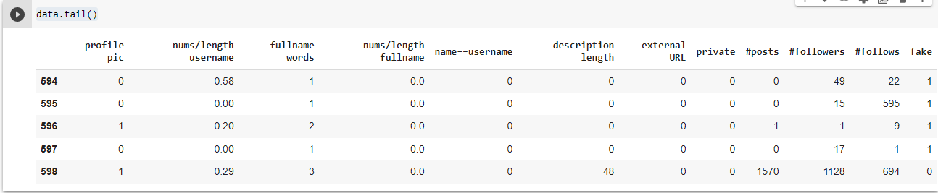

data.shape



plt.scatter(data["name==username"],data["fake"])

plt.show

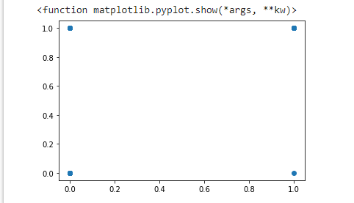

y_data = data[["fake"]]

x_data = data.drop(columns={'fake'})

y_data.head()

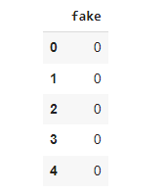

X_train , X_test , Y_train , Y_test = train_test_split(x_data, y_data, test_size= 0.2 , random_state=1)

logistic_model = LogisticRegression()

logistic_model.fit(X_train, Y_train)

predicted = logistic_model.predict(X_test)

predicted

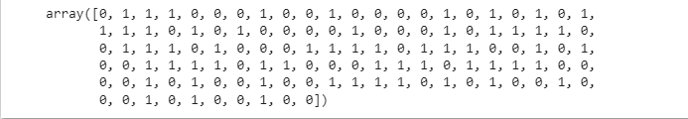

predicted_df = pd.DataFrame(data=predicted)

predicted_df

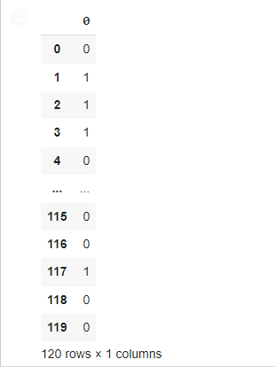

fc = confusion_matrix(Y_test, predicted_df)

sns.heatmap(fc, annot = True)

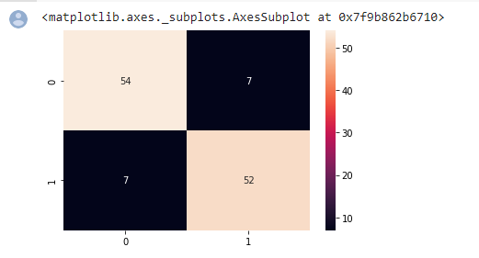

accuracy = ((fc[0,0] + fc[1,1]) /(fc[0,0]+fc[0,1]+fc[1,0]+fc[1,1]))*100

print(round(accuracy,2))



error = 100 - accuracy

print(round(error,2))



score = logistic_model.score(X_test, Y_test)

score*100



score1 = accuracy_score(Y_test, predicted_df)

score1



print('Precision %.3f'% precision_score(Y_test, predicted_df))



print('Recall_score.%3f'% roc_auc_score(Y_test, predicted_df))



print('F1_score.%3f'% f1_score(Y_test, predicted_df))



* #random forest

clf = RandomForestClassifier()

clf.fit(X_train, Y_train)

predicted =clf.predict(X_test)

predicted_df = pd.DataFrame(data=predicted)

predicted_df

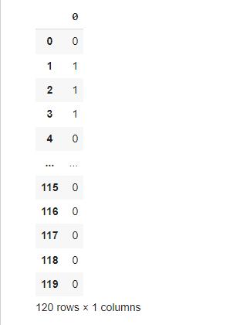

fc = confusion_matrix(Y_test, predicted_df)

sns.heatmap(fc, annot = True)

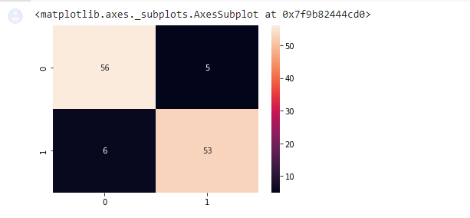

accuracy = ((fc[0,0] + fc[1,1]) /(fc[0,0]+fc[0,1]+fc[1,0]+fc[1,1]))*100

print(round(accuracy,2))



**1B] Implement and demonstrate the FIND-S algorithm for finding the most specific hypothesis based on a given set of training data samples. Read the training data from a .CSV file**

# -*- coding: utf-8 -*-

"""Find S Algo.ipynb

Automatically generated by Colaboratory.

Original file is located at

# **PART1: IMPORTING PACKAGES**

"""

Importnumpy as np

import pandas as pd

"""# **PART2: READING DATA**"""

data = pd.read_csv("ws.csv")

data

data.shape

"""# **PART3: SPLITTING X AND Y PART FROM THE DATA**"""

concepts = np.array(data)[:,:-1]

concepts

target = np.array(data)[:,-1]

target

"""# **PART4: TRAINING PART**"""

def train(c,t):

    for i, val in enumerate(t):

        ifval == "Yes":

            specific_hypothesis = c[i].copy()

            break

    for i, val in enumerate(c):

        if t[i] == "Yes":

            for x in range(len(specific_hypothesis)):

                ifval[x] != specific_hypothesis[x]:

                    specific_hypothesis[x] = '?'

                else:

                    pass

    returnspecific_hypothesis

"""# **PART 5: TESTING PART**"""

print(train(concepts, target))

**Output**

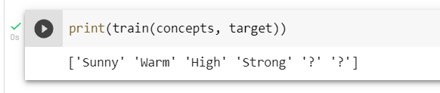

**PRACTICAL: 2**

**2A] Perform Data Loading, Feature selection (Principal Component analysis) andFeature Scoring and Ranking.**

import pandas as pd

df = pd.read_csv("/content/heart.csv")

df.head()

df.shape

df.describe()

df[df.Cholesterol>(df.Cholesterol.mean()+3*df.Cholesterol.std())]

df.shape

df[df.MaxHR>(df.MaxHR.mean()+3*df.MaxHR.std())]

df[df.FastingBS>(df.FastingBS.mean()+3*df.FastingBS.std())]

df[df.Oldpeak>(df.Oldpeak.mean()+3*df.Oldpeak.std())]

df2 = df1[df1.Oldpeak<=(df1.Oldpeak.mean()+3*df1.Oldpeak.std())]

df2.shape

df[df.RestingBP>(df.RestingBP.mean()+3*df.RestingBP.std())]

df3 = df2[df2.RestingBP<=(df2.RestingBP.mean()+3*df2.RestingBP.std())]

df3.shape

df.ChestPainType.unique()

df.RestingECG.unique()

df.ExerciseAngina.unique()

df.ST_Slope.unique()

df4 = df3.copy()

df4.ExerciseAngina.replace(

    {

        'N': 0,

        'Y': 1

    },

    inplace=True)

df4.ST_Slope.replace(

    {

        'Down': 1,

        'Flat': 2,

        'Up': 3

    },

    inplace=True

)

df4.RestingECG.replace(

    {

        'Normal': 1,

        'ST': 2,

        'LVH': 3

    },

    inplace=True)

df4.head()

df5 = pd.get_dummies(df4, drop_first=True)

df5.head()

X = df5.drop("HeartDisease",axis='columns')

y = df5.HeartDisease

X.head()

from sklearn.preprocessing import StandardScaler

scaler = StandardScaler()

X_scaled = scaler.fit_transform(X)

X_scaled

from sklearn.model_selection import train_test_split

X_train.shape

X_test.shape

from sklearn.ensemble import RandomForestClassifier

from sklearn.decomposition import PCA

pca = PCA(0.95)

X_pca = pca.fit_transform(X)

X_pca

X_train_pca, X_test_pca, y_train, y_test = train_test_split(X_pca, y, test_size=0.2, random_state=30)

from sklearn.ensemble import RandomForestClassifier

model_rf = RandomForestClassifier()

model_rf.fit(X_train_pca, y_train)

model_rf.score(X_test_pca, y_test)

**Output**

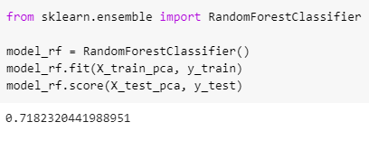

**2B] For a given set of training data examples stored in a .CSV file, implement and demonstrate the Candidate-Elimination algorithm to output a description of the set of all hypotheses consistent with the training examples.**

import numpy as np

import pandas as pd

data = pd.read_csv('/content/drive/MyDrive/data set/sport.csv')

concepts = np.array(data.iloc[:,0:-1])

print("\nInstances are:\n",concepts)

target = np.array(data.iloc[:,-1])

print("\nTarget Values are: ",target)

**Output**

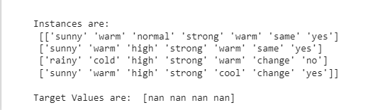

def learn(concepts, target):

    specific_h = concepts[0].copy()

    print("\nInitialization of specific_h and genearal_h")

    print("\nSpecific Boundary: ", specific_h)

    general_h = [["?" for i in range(len(specific_h))] for i in range(len(specific_h))]

    print("\nGeneric Boundary: ",general_h)

    for i, h in enumerate(concepts):

        print("\nInstance", i+1 , "is ", h)

        if target[i] == "yes":

            print("Instance is Positive ")

            for x in range(len (specific_h)):

                if h[x]!= specific_h[x]:

                    specific_h[x] ='?'

                    general_h[x][x] ='?'

        if target[i] == "no":

            print("Instance is Negative ")

            for x in range(len(specific_h)):

                if h[x]!= specific_h[x]:

                    general_h[x][x] = specific_h[x]

                else:

                    general_h[x][x] = '?'

        print("Specific Bundary after ", i+1, "Instance is ", specific_h)

        print("Generic Boundary after ", i+1, "Instance is ", general_h)

        print("\n")

    indices = [i for i, val in enumerate(general_h) if val == ['?', '?', '?', '?', '?', '?']]

    for i in indices:

        general_h.remove(['?', '?', '?', '?', '?', '?'])

    return specific_h, general_h

s_final, g_final = learn(concepts, target)

print("Final Specific_h: ", s_final, sep="\n")

print("Final General_h: ", g_final, sep="\n")

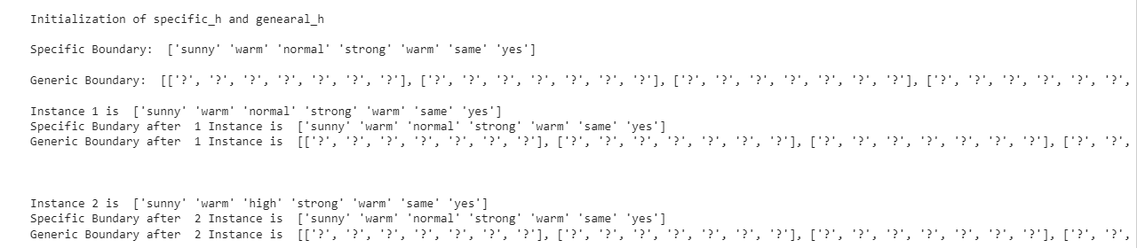

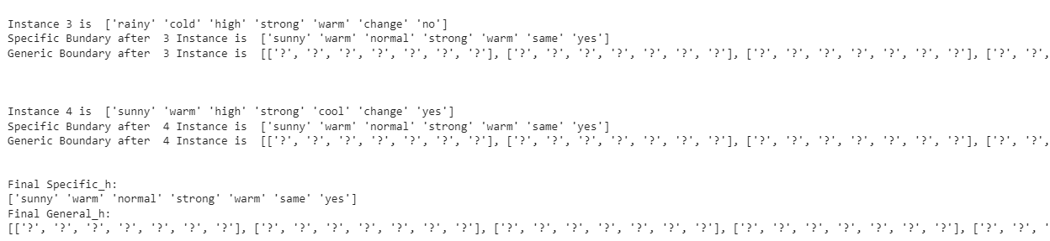

**PRACTICAL: 3**

**3A]Write a program to implement the naïve Bayesian classifier for a sample training data set stored as a .CSV file. Compute the accuracy of the classifier, considering few test data sets.**

import pandas as pd

df = pd.read_csv("spam.csv")

df.head()

**output**

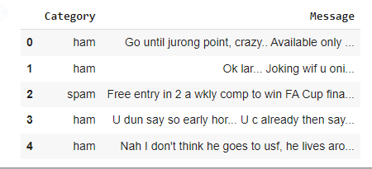

df.groupby('Category').describe()

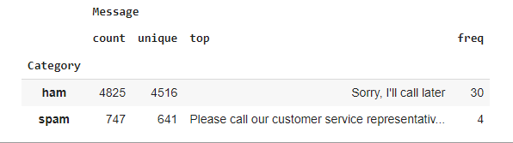

df['spam']=df['Category'].apply(lambda x: 1 if x=='spam' else 0)

df.head()

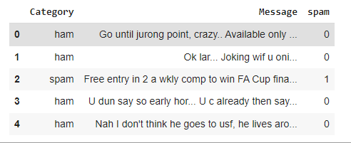

from sklearn.model_selection import train_test_split

X_train, X_test, y_train, y_test = train_test_split(df.Message,df.spam)

from sklearn.feature_extraction.text import CountVectorizer

v = CountVectorizer()

X_train_count = v.fit_transform(X_train.values)

X_train_count.toarray()[:2]



from sklearn.naive_bayes import MultinomialNB

model = MultinomialNB()

model.fit(X_train_count,y_train)



emails = [

    'Hey mohan, can we get together to watch footbal game tomorrow?',

    'Upto 20% discount on parking, exclusive offer just for you. Dont miss this reward!'

]

emails_count = v.transform(emails)

model.predict(emails_count)



X_test_count = v.transform(X_test)

model.score(X_test_count, y_test)



**Sklearn Pipeline**

from sklearn.pipeline import Pipeline

clf = Pipeline([

    ('vectorizer', CountVectorizer()),

    ('nb', MultinomialNB())

])

clf.fit(X_train, y_train)

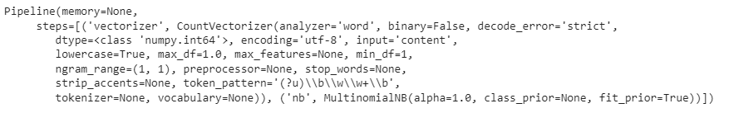

clf.score(X_test,y_test)



clf.predict(emails)



**3B]Write a program to implement Decision Tree and Random forest with Prediction, Test Score and Confusion Matrix.**

import numpy as nm

import matplotlib.pyplot as mtp

import pandas as pd

from sklearn.preprocessing import LabelEncoder

from sklearn import preprocessing

from google.colab import drive

drive.mount('/content/drive')

#importing datasets

data_set= pd.read_csv("/content/drive/MyDrive/dataset/iris.csv")

data_set

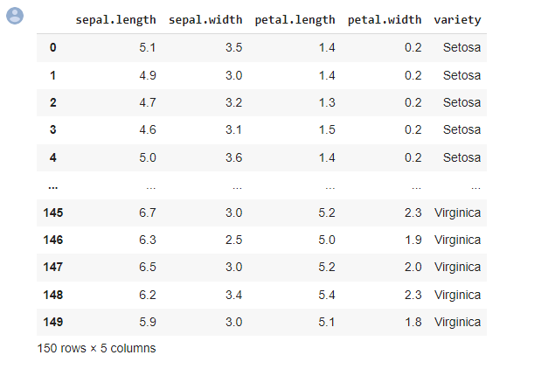

le = preprocessing.LabelEncoder()

data_set["variety"] = le.fit_transform(data_set["variety"])

data_set.head()

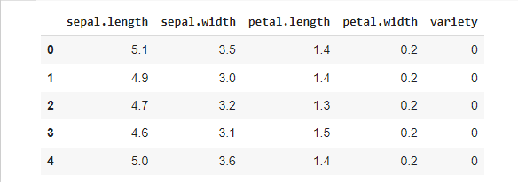

x_data= data_set.iloc[:, [0,1,2,3]].values

y_data= data_set.iloc[:, 4].values

x_data

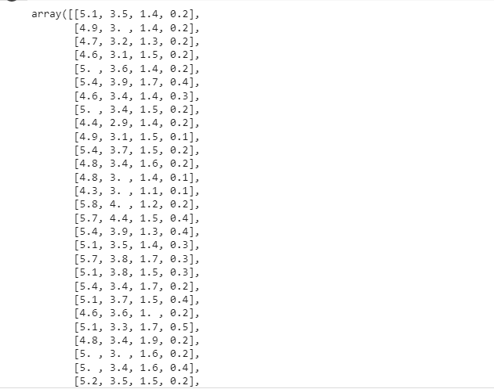

y_data

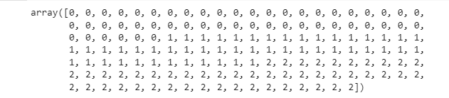

# Splitting the dataset into training and test set.

from sklearn.model_selection import train_test_split

x_train, x_test, y_train, y_test= train_test_split(x_data, y_data, test_size= 0.20, random_state=1)

#feature Scaling

from sklearn.preprocessing import StandardScaler

st_x= StandardScaler()

x_train= st_x.fit_transform(x_train)

x_test= st_x.transform(x_test)

#Fitting Decision Tree classifier to the training set

from sklearn.ensemble import RandomForestClassifier

classifier= RandomForestClassifier(n_estimators= 10, criterion="entropy")

classifier.fit(x_train, y_train)

#Predicting the test set result

y_pred= classifier.predict(x_test)

y_pred



#Creating the Confusion matrix

from sklearn.metrics import classification_report, confusion_matrix, accuracy_score

print(confusion_matrix(y_test,y_pred))

print(classification_report(y_test,y_pred))

print(accuracy_score(y_test, y_pred))

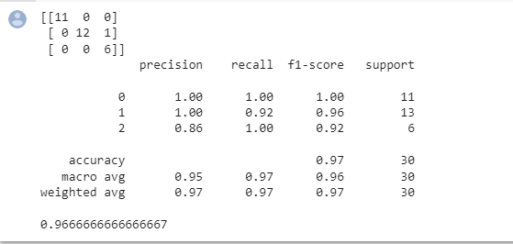

**PRACTICAL: 4**

**4A]For a given set of training data examples stored in a .CSV file implement LeastSquare Regression algorithm.**

**Code:**

importnumpy as np

import pandas as pd

importmatplotlib.pyplot as plt

data= pd.read_csv('/content/drive/MyDrive/data set/pract4A.csv')

data.head()

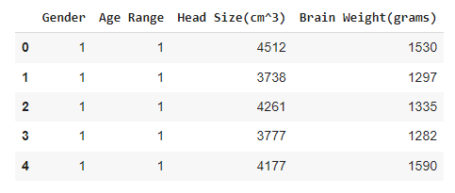

# Coomputing X and Y

X = data['Head Size(cm^3)'].values

Y = data['Brain Weight(grams)'].values

# Mean X and Y

mean_x = np.mean(X)

mean_y = np.mean(Y)

# Total number of values

n = len(X)

# Using the formula to calculate 'm' and 'c'

numer = 0

denom = 0

for i in range(n):

  numer += (X[i] - mean_x) * (Y[i] - mean_y)

  denom += (X[i] - mean_x) ** 2

m = numer / denom

c = mean_y - (m * mean_x)

# Printing coefficients

print("Coefficients")

print(m, c)



# Plotting Values and Regression Line

 max_x = np.max(X) + 100

min_x = np.min(X) - 100

# Calculating line values x and y

x = np.linspace(min_x, max_x, 1000)

y = c + m * x

# Ploting Line

plt.plot(x, y, color='#58b970', label='Regression Line')

# Ploting Scatter Points

plt.scatter(X, Y, c='#ef5423', label='Scatter Plot')

plt.xlabel('Head Size in cm3')

plt.ylabel('Brain Weight in grams')

plt.legend()

plt.show()

**output:**

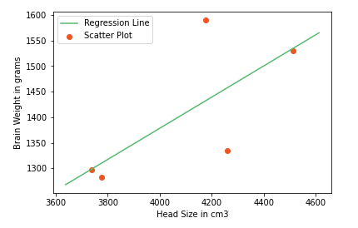

# Calculating Root Mean Squares Error

rmse = 0

for i in range(n):

    y_pred = c + m * X[i]

    rmse += (Y[i] - y_pred) ** 2

rmse = np.sqrt(rmse/n)

print("RMSE")

print(rmse)



**4B] For a given set of training data examples stored in a .CSV file implement Logistic Regression algorithm.**

import pandas as pd  
import numpy as np  
import matplotlib.pyplot as plt  
import seaborn as sns  
%matplotlib inline  
train = pd.read_csv('titanic_train.csv')  
[train.info](http://train.info/)()  
sns.heatmap(train.isnull(),yticklabels=False,cbar=False,cmap='viridis')  
def impute_age(cols):  
    Age = cols[0]  
    Pclass = cols[1]  
     
    if pd.isnull(Age):  
  
        if Pclass == 1:  
            return 37  
  
        elif Pclass == 2:  
            return 29  
  
        else:  
            return 24  
  
    else:  
        return Age  
  
train['Age'] = train[['Age','Pclass']].apply(impute_age,axis=1)  
sns.heatmap(train.isnull(),yticklabels=False,cbar=False,cmap='viridis')  
train.drop('Cabin',axis=1,inplace=True)  
train.dropna(inplace=True)  
sex = pd.get_dummies(train['Sex'],drop_first=True)  
embark = pd.get_dummies(train['Embarked'],drop_first=True)  
  
train.drop(['Sex','Embarked','Name','Ticket'],axis=1,inplace=True)  
  
train = pd.concat([train,sex,embark],axis=1)  
from sklearn.model_selection import train_test_split  
X_train, X_test, y_train, y_test = train_test_split(train.drop('Survived',axis=1),  
                                                    train['Survived'], test_size=0.30, random_state=101)  
from sklearn.linear_model import LogisticRegression  
logmodel = LogisticRegression()  
logmodel.fit(X_train,y_train)  
predictions = logmodel.predict(X_test)  
from sklearn.metrics import classification_report

print(classification_report(y_test,predictions))

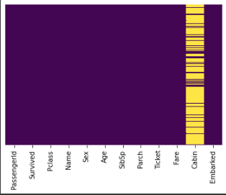

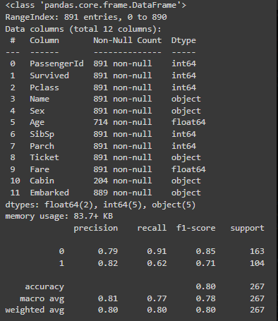

**PRACTICAL: 5**

**5A]Write a program to demonstrate the working of the decision tree based ID3 algorithm. Use an appropriate data set for building the decision tree and apply this knowledge to classify a new sample.**

import pandas as pd

import math

import numpy as np

data = pd.read_csv("/content/drive/MyDrive/dataset/dataset.csv")

features = [feat for feat in data]

features.remove("answer")

class Node:

    def __init__(self):

        self.children = []

        self.value = ""

        self.isLeaf = False

        self.pred = ""

def entropy(examples):

    pos = 0.0

    neg = 0.0

    for _, row in examples.iterrows():

        if row["answer"] == "yes":

            pos += 1

        else:

            neg += 1

    if pos == 0.0 or neg == 0.0:

        return 0.0

    else:

        p = pos / (pos + neg)

        n = neg / (pos + neg)

        return -(p * math.log(p, 2) + n * math.log(n, 2))

def info_gain(examples, attr):

    uniq = np.unique(examples[attr])

    #print ("\n",uniq)

    gain = entropy(examples)

    #print ("\n",gain)

    for u in uniq:

        subdata = examples[examples[attr] == u]

        #print ("\n",subdata)

        sub_e = entropy(subdata)

        gain -= (float(len(subdata)) / float(len(examples))) * sub_e

        #print ("\n",gain)

    return gain

def ID3(examples, attrs):

    root = Node()

    max_gain = 0

    max_feat = ""

    for feature in attrs:

        #print ("\n",examples)

        gain = info_gain(examples, feature)

        if gain > max_gain:

            max_gain = gain

            max_feat = feature

    root.value = max_feat

    #print ("\nMax feature attr",max_feat)

    uniq = np.unique(examples[max_feat])

    #print ("\n",uniq)

    for u in uniq:

        #print ("\n",u)

        subdata = examples[examples[max_feat] == u]

        #print ("\n",subdata)

        if entropy(subdata) == 0.0:

            newNode = Node()

            newNode.isLeaf = True

            newNode.value = u

            newNode.pred = np.unique(subdata["answer"])

            root.children.append(newNode)

        else:

            dummyNode = Node()

            dummyNode.value = u

            new_attrs = attrs.copy()

            new_attrs.remove(max_feat)

            child = ID3(subdata, new_attrs)

            dummyNode.children.append(child)

            root.children.append(dummyNode)

    return root

def printTree(root: Node, depth=0):

    for i in range(depth):

        print("\t", end="")

    print(root.value, end="")

    if root.isLeaf:

        print(" -> ", root.pred)

    print()

    for child in root.children:

        printTree(child, depth + 1)

def classify(root: Node, new):

    for child in root.children:

        if child.value == new[root.value]:

            if child.isLeaf:

                print ("Predicted Label for new example", new," is:", child.pred)

                exit

            else:

                classify (child.children[0], new)

root = ID3(data, features)

print("Decision Tree is:")

printTree(root)

print ("------------------")

new = {"outlook":"sunny", "temperature":"hot", "humidity":"normal", "wind":"strong"}

classify (root, new)

**Output**

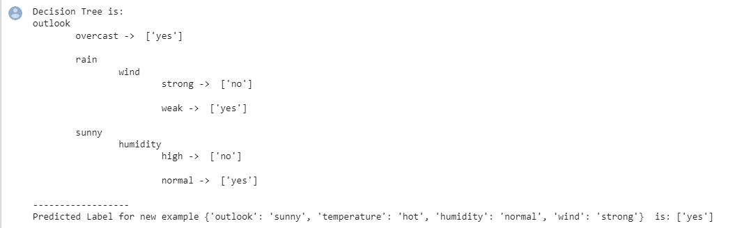

**5B]** **Write a program to implement k-Nearest Neighbour algorithm to classify the iris data set.**

from sklearn.model_selection import train_test_split

from sklearn.neighbors import KNeighborsClassifier

from sklearn.metrics import classification_report, confusion_matrix

from sklearn import datasets

iris=datasets.load_iris()

x = iris.data

y = iris.target

print ('sepal-length', 'sepal-width', 'petal-length', 'petal-width')

print(x)

print('class: 0-Iris-Setosa, 1- Iris-Versicolour, 2- Iris-Virginica')

print(y)

x_train, x_test, y_train, y_test = train_test_split(x,y,test_size=0.3)

#To Training the model and Nearest nighbors K=5

classifier = KNeighborsClassifier(n_neighbors=5)

classifier.fit(x_train, y_train)

#To make predictions on our test data

y_pred=classifier.predict(x_test)

print('Confusion Matrix')

print(confusion_matrix(y_test,y_pred))

print('Accuracy Metrics')

print(classification_report(y_test,y_pred))

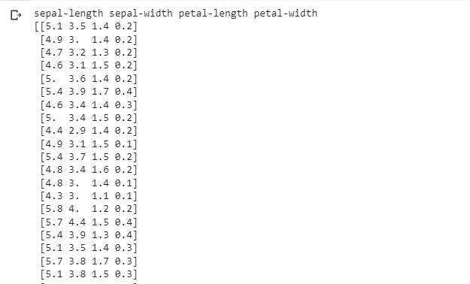

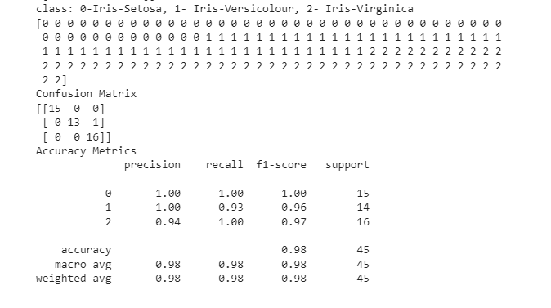

**PRACTICAL: 6**

**6A]Implement the different Distance methods (Euclidean) with Prediction, Test Score and Confusion Matrix.**

fromsklearn.neighbors import KNeighborsClassifier

fromsklearn.metrics import confusion_matrix, accuracy_score

fromsklearn.model_selection import train_test_split

importnumpy as np

# Generate some random data for demonstration

X = np.random.rand(100, 2)

y = np.random.randint(0, 2, 100)

# Split the data into training and test sets

X_train, X_test, y_train, y_test = train_test_split(X, y, test_size=0.2)

# Initialize the KNN classifier with the Euclidean distance metric

clf = KNeighborsClassifier(metric='euclidean')

# Fit the model to the training data

clf.fit(X_train, y_train)

# Make predictions on the test set

y_pred = clf.predict(X_test)

# Calculate the test score (accuracy)

test_score = accuracy_score(y_test, y_pred)

print("Test Score: ", test_score)

# Calculate the confusion matrix

confusion_mat = confusion_matrix(y_test, y_pred)

print("Confusion Matrix: \n", confusion_mat)

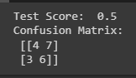

**6B]Implement the classification model using clustering for the following techniques with K means clustering with Prediction, Test Score and Confusion Matrix**

fromsklearn.cluster import KMeans

fromsklearn.metrics import accuracy_score, confusion_matrix

fromsklearn.model_selection import train_test_split

importnumpy as np

# Generate some random data for demonstration

X = np.random.rand(100, 2)

y = np.random.randint(0, 2, 100)

# Split the data into training and test sets

X_train, X_test, y_train, y_test = train_test_split(X, y, test_size=0.2)

# Initialize the K-means clustering model

kmeans = KMeans(n_clusters=2)

# Fit the model to the training data

kmeans.fit(X_train)

# Assign labels to the test data based on the cluster centers

y_pred = kmeans.predict(X_test)

# Create a mapping from the cluster labels to the original labels

# This step is needed because the k-means algorithm does not guarantee

# that the clusters will correspond to the original labels

label_map = dict(zip(np.unique(y_train), np.unique(y)))

y_pred = np.array([label_map[label] for label in y_pred])

print("Predicted Label for the new data point: ", y_pred )

# Calculate the test score (accuracy)

test_score = accuracy_score(y_test, y_pred)

print("Test Score: ", test_score)

# Calculate the confusion matrix

confusion_mat = confusion_matrix(y_test, y_pred)

print("Confusion Matrix: \n", confusion_mat)

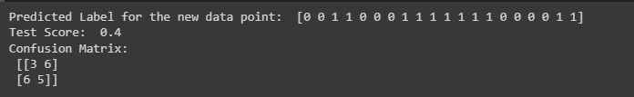

**PRACTICAL: 7**

**7A]Implement the classification model using clustering for the following techniques with hierarchical clustering with Prediction, Test Score and Confusion Matrix**

import pandas as pd

import numpy as np

import matplotlib.pyplot as plt

import seaborn as sns

comic_con = pd.read_csv('/content/CLUSTERING.csv', index_col=0)

comic_con.head()

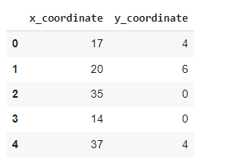

from google.colab import drive

drive.mount('/content/drive')



from scipy.cluster.vq import whiten

comic_con['x_scaled'] = whiten(comic_con['x_coordinate'])

comic_con['y_scaled'] = whiten(comic_con['y_coordinate'])

from scipy.cluster.hierarchy import linkage, fcluster

# Use the linkage()

distance_matrix = linkage(comic_con[['x_scaled', 'y_scaled']], method='ward', metric='euclidean')

# Assign cluster labels

comic_con['cluster_labels'] = fcluster(distance_matrix, 2, criterion='maxclust')

# Plot clusters

sns.scatterplot(x='x_scaled', y='y_scaled', hue='cluster_labels', data=comic_con);

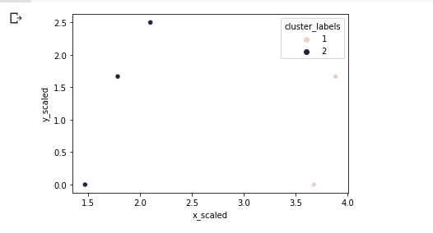

# Use the linkage()

distance_matrix = linkage(comic_con[['x_scaled', 'y_scaled']], method='single', metric='euclidean')

# Assign cluster labels

comic_con['cluster_labels'] = fcluster(distance_matrix, 2, criterion='maxclust')

# Plot clusters

sns.scatterplot(x='x_scaled', y='y_scaled', hue='cluster_labels', data=comic_con);

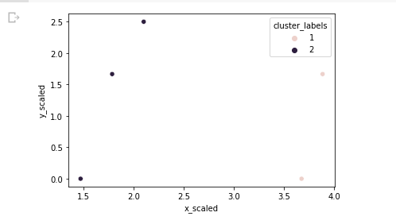

# Use the linkage()

distance_matrix = linkage(comic_con[['x_scaled', 'y_scaled']], method='complete', metric='euclidean')

# Assign cluster labels

comic_con['cluster_labels'] = fcluster(distance_matrix, 2, criterion='maxclust')

# Plot clusters

sns.scatterplot(x='x_scaled', y='y_scaled', hue='cluster_labels', data=comic_con);

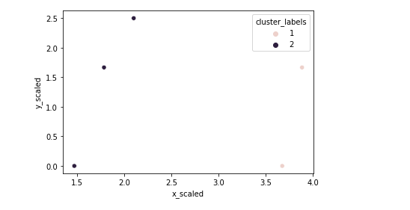

# Define a colors dictionary for clusters

colors = {1:'red', 2:'blue'}

# Plot the scatter plot

comic_con.plot.scatter(x='x_scaled', y='y_scaled', c=comic_con['cluster_labels'].apply(lambda x: colors[x]));

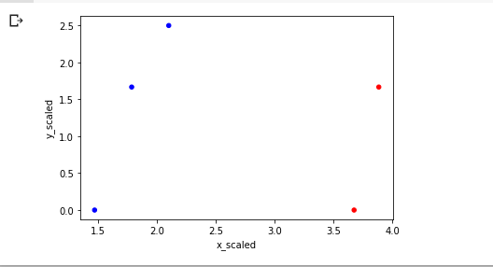

# Plot a scatter plot using seaborn

sns.scatterplot(x='x_scaled', y='y_scaled', hue='cluster_labels', data=comic_con)

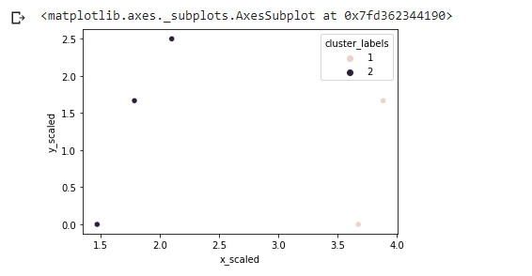

from scipy.cluster.hierarchy import dendrogram

# Create a dendrogram

dn = dendrogram(distance_matrix)

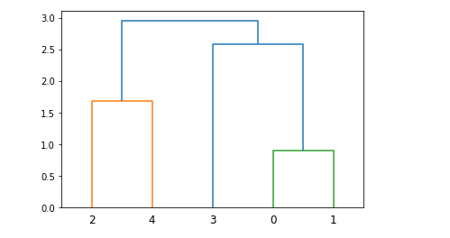

%timeit linkage(comic_con[['x_scaled', 'y_scaled']], method='ward', metric='euclidean')



fifa = pd.read_csv('/content/drive/MyDrive/data set/fifa18.csv')

fifa.head()

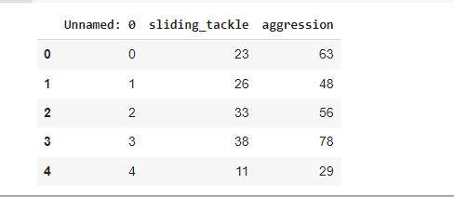

fifa['scaled_sliding_tackle'] = whiten(fifa['sliding_tackle'])

fifa['scaled_aggression'] = whiten(fifa['aggression'])

# Fit the data into a hierarchical cluster

distance_matrix = linkage(fifa[['scaled_sliding_tackle', 'scaled_aggression']], method='ward')

# Assign cluster labels to each row of data

fifa['cluster_labels'] = fcluster(distance_matrix, 3, criterion='maxclust')

# Display cluster centers of each cluster

print(fifa[['scaled_sliding_tackle', 'scaled_aggression', 'cluster_labels']].groupby('cluster_labels').mean())

# Create a scatter plot through seaborn

sns.scatterplot(x='scaled_sliding_tackle', y='scaled_aggression', hue='cluster_labels', data=fifa)

plt.savefig('/content/drive/MyDrive/data set/fifa_cluster.png')

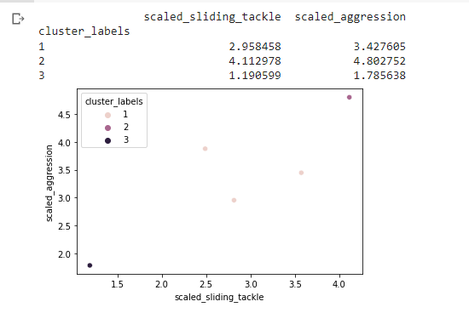

**7B]Implement the Rule based method and test the same.**

from sklearn.metrics import accuracy_score, confusion_matrix  
from sklearn.model_selection import train_test_split  
import numpy as np  
  
# Generate some random data for demonstration  
X = np.random.rand(100, 2)  
y = np.random.randint(0, 2, 100)  
  
# Split the data into training and test sets  
X_train, X_test, y_train, y_test = train_test_split(X, y, test_size=0.2)  
  
# Define the rule-based classifier  
defrule_based_classifier(x):  
    if x[0] > x[1]:  
        return 0  
    else:  
        return 1  
  
# Make predictions on the test set using the rule-based classifier  
y_pred = np.array([rule_based_classifier(x) for x in X_test])  
  
# Calculate the test score (accuracy)  
test_score = accuracy_score(y_test, y_pred)  
print("Test Score: ", test_score)  
  
# Calculate the confusion matrix  
confusion_mat = confusion_matrix(y_test, y_pred)  
print("Confusion Matrix: \n", confusion_mat)

**Output**

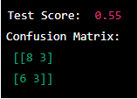

**PRACTICAL: 8**

**8A]Write a program to construct a Bayesian network considering medical data. Use this**

**model to demonstrate the diagnosis of heart patients using standard Heart Disease**

**Data Set.**

pip install pgmpy

import pandas as pd

from pgmpy.estimators import MaximumLikelihoodEstimator

from pgmpy.models import BayesianModel

from pgmpy.inference import VariableElimination

data = pd.read_csv("/content/drive/MyDrive/ml dataset/DS4.csv")

heart_disease = pd.DataFrame(data)

print(heart_disease)

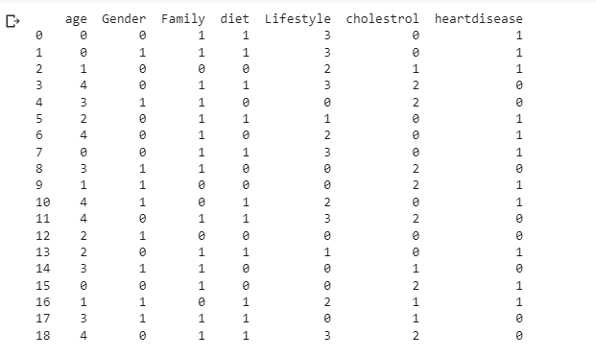

model = BayesianModel([

('age', 'Lifestyle'),

('Gender', 'Lifestyle'),

('Family', 'heartdisease'),

('diet', 'cholestrol'),

('Lifestyle', 'diet'),

('cholestrol', 'heartdisease'),

('diet', 'cholestrol')

])

model.fit(heart_disease, estimator=MaximumLikelihoodEstimator)

HeartDisease_infer = VariableElimination(model)

print('For Age enter SuperSeniorCitizen:0, SeniorCitizen:1, MiddleAged:2, Youth:3, Teen:4')

print('For Gender enter Male:0, Female:1')

print('For Family History enter Yes:1, No:0')

print('For Diet enter High:0, Medium:1')

print('for LifeStyle enter Athlete:0, Active:1, Moderate:2, Sedentary:3')

print('for Cholesterol enter High:0, BorderLine:1, Normal:2')

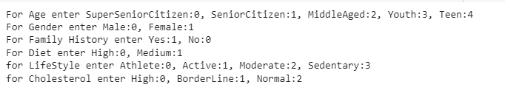

q = HeartDisease_infer.query(variables=['heartdisease'], evidence={

'age': int(input('Enter Age: ')),

'Gender': int(input('Enter Gender: ')),

'Family': int(input('Enter Family History: ')),

'diet': int(input('Enter Diet: ')),

'Lifestyle': int(input('Enter Lifestyle: ')),

'cholestrol': int(input('Enter Cholestrol: '))

})

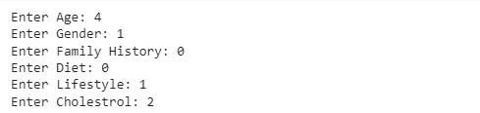

print(q)

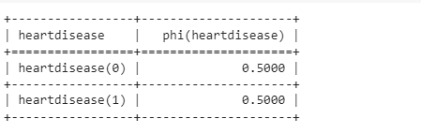

**8B]Implement the non-parametric Locally Weighted Regression algorithm in order to fit data points. Select appropriate data set for your experiment and draw graphs.**

from sklearn.linear_model import LinearRegression  
from sklearn.metrics import mean_squared_error  
from sklearn.model_selection import train_test_split  
import numpy as np  
import matplotlib.pyplot as plt  
  
# Generate some random data for demonstration  
np.random.seed(0)  
X = np.random.rand(100, 1)  
y = np.sin(2 * np.pi * X) + np.random.randn(100, 1) * 0.1  
  
# Split the data into training and test sets  
X_train, X_test, y_train, y_test = train_test_split(X, y, test_size=0.2)  
  
# Initialize the LWR model  
lwr = LinearRegression(fit_intercept=True)  
  
# Define the bandwidth parameter  
bandwidth = 0.2  
  
# Fit the model to the training data  
predictions = []  
for x in X_test:  
    weights = np.exp(-((X_train - x) ** 2) / (2 * bandwidth ** 2))  
    lwr.fit(X_train, y_train, sample_weight=weights)  
    predictions.append(lwr.predict([x]))  
  
# Calculate the test MSE  
test_mse = mean_squared_error(y_test, predictions)  
print("Test MSE: ", test_mse)  
  
# Plot the data points and the LWR model  
plt.scatter(X_train, y_train, label='Training Data')  
plt.scatter(X_test, y_test, label='Test Data')  
plt.plot(X_test, predictions, color='r', label='LWR Model')  
plt.legend()  
plt.show()

**Output**



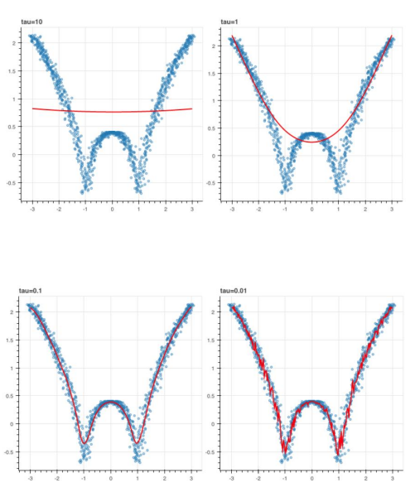

**PRACTICAL: 9**

**9A]Build an Artificial Neural Network by implementing the Backpropagation algorithm and test the same using appropriate data sets.**

import numpy as np

X = np.array(([2, 9], [1, 5], [3, 6]), dtype=float)

y = np.array(([92], [86], [89]), dtype=float)

X = X/np.amax(X,axis=0) # maximum of X array longitudinally

y = y/100

#Sigmoid Function

def sigmoid (x):

 return 1/(1 + np.exp(-x))

#Derivative of Sigmoid Function

def derivatives_sigmoid(x):

 return x * (1 - x)

#Variable initialization

epoch=5000 #Setting training iterations

lr=0.1 #Setting learning rate

inputlayer_neurons = 2 #number of features in data set

hiddenlayer_neurons = 3 #number of hidden layers neurons

output_neurons = 1 #number of neurons at output layer

#weight and bias initialization

wh=np.random.uniform(size=(inputlayer_neurons,hiddenlayer_neurons))

bh=np.random.uniform(size=(1,hiddenlayer_neurons))

wout=np.random.uniform(size=(hiddenlayer_neurons,output_neurons))

bout=np.random.uniform(size=(1,output_neurons))

#draws a random range of numbers uniformly of dim x*y

for i in range(epoch):

#Forward Propogation

 hinp1=np.dot(X,wh)

 hinp=hinp1 + bh

 hlayer_act = sigmoid(hinp)

 outinp1=np.dot(hlayer_act,wout)

 outinp= outinp1+ bout

 output = sigmoid(outinp)

#Backpropagation

 EO = y-output

 outgrad = derivatives_sigmoid(output)

 d_output = EO* outgrad

 EH = d_output.dot(wout.T)

#how much hidden layer wts contributed to error

 hiddengrad = derivatives_sigmoid(hlayer_act)

 d_hiddenlayer = EH * hiddengrad

# dotproduct of nextlayererror and currentlayerop

wout += hlayer_act.T.dot(d_output) *lr

wh += X.T.dot(d_hiddenlayer) *lr

print("Input: \n" + str(X))

print("Actual Output: \n" + str(y))

print("Predicted Output: \n" ,output)

**Output**

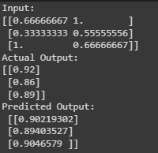

**9B]** **Assuming a set of documents that need to be classified, use the naïve Bayesian Classifier model to perform this task.**

pip install pgmpy

import pandas as pd

from pgmpy.estimators import MaximumLikelihoodEstimator

from pgmpy.models import BayesianModel

from pgmpy.inference import VariableElimination

data = pd.read_csv("/content/drive/MyDrive/ml dataset/DS4.csv")

heart_disease = pd.DataFrame(data)

print(heart_disease)



model = BayesianModel([

('age', 'Lifestyle'),

('Gender', 'Lifestyle'),

('Family', 'heartdisease'),

('diet', 'cholestrol'),

('Lifestyle', 'diet'),

('cholestrol', 'heartdisease'),

('diet', 'cholestrol')

])

model.fit(heart_disease, estimator=MaximumLikelihoodEstimator)

HeartDisease_infer = VariableElimination(model)

print('For Age enter SuperSeniorCitizen:0, SeniorCitizen:1, MiddleAged:2, Youth:3, Teen:4')

print('For Gender enter Male:0, Female:1')

print('For Family History enter Yes:1, No:0')

print('For Diet enter High:0, Medium:1')

print('for LifeStyle enter Athlete:0, Active:1, Moderate:2, Sedentary:3')

print('for Cholesterol enter High:0, BorderLine:1, Normal:2')



q = HeartDisease_infer.query(variables=['heartdisease'], evidence={

'age': int(input('Enter Age: ')),

'Gender': int(input('Enter Gender: ')),

'Family': int(input('Enter Family History: ')),

'diet': int(input('Enter Diet: ')),

'Lifestyle': int(input('Enter Lifestyle: ')),

'cholestrol': int(input('Enter Cholestrol: '))

})



print(q)



**PRACTICAL: 10**

**10A] Write A Program To Demonstrate The Working Of The Decision Tree Based ID3 Algorithm. Use An Appropriate Data Set For Building The Decision Tree And Apply This Knowledge To Classify A New Sample.**

import pandas as pd

import math

import numpy as np

data = pd.read_csv("/content/drive/MyDrive/dataset/dataset.csv")

features = [feat for feat in data]

features.remove("answer")

class Node:

    def __init__(self):

        self.children = []

        self.value = ""

        self.isLeaf = False

        self.pred = ""

def entropy(examples):

    pos = 0.0

    neg = 0.0

    for _, row in examples.iterrows():

        if row["answer"] == "yes":

            pos += 1

        else:

            neg += 1

    if pos == 0.0 or neg == 0.0:

        return 0.0

    else:

        p = pos / (pos + neg)

        n = neg / (pos + neg)

        return -(p * math.log(p, 2) + n * math.log(n, 2))

def info_gain(examples, attr):

    uniq = np.unique(examples[attr])

    #print ("\n",uniq)

    gain = entropy(examples)

    #print ("\n",gain)

    for u in uniq:

        subdata = examples[examples[attr] == u]

        #print ("\n",subdata)

        sub_e = entropy(subdata)

        gain -= (float(len(subdata)) / float(len(examples))) * sub_e

        #print ("\n",gain)

    return gain

def ID3(examples, attrs):

    root = Node()

    max_gain = 0

    max_feat = ""

    for feature in attrs:

        #print ("\n",examples)

        gain = info_gain(examples, feature)

        if gain > max_gain:

            max_gain = gain

            max_feat = feature

    root.value = max_feat

    #print ("\nMax feature attr",max_feat)

    uniq = np.unique(examples[max_feat])

    #print ("\n",uniq)

    for u in uniq:

        #print ("\n",u)

        subdata = examples[examples[max_feat] == u]

        #print ("\n",subdata)

        if entropy(subdata) == 0.0:

            newNode = Node()

            newNode.isLeaf = True

            newNode.value = u

            newNode.pred = np.unique(subdata["answer"])

            root.children.append(newNode)

        else:

            dummyNode = Node()

            dummyNode.value = u

            new_attrs = attrs.copy()

            new_attrs.remove(max_feat)

            child = ID3(subdata, new_attrs)

            dummyNode.children.append(child)

            root.children.append(dummyNode)

    return root

def printTree(root: Node, depth=0):

    for i in range(depth):

        print("\t", end="")

    print(root.value, end="")

    if root.isLeaf:

        print(" -> ", root.pred)

    print()

    for child in root.children:

        printTree(child, depth + 1)

def classify(root: Node, new):

    for child in root.children:

        if child.value == new[root.value]:

            if child.isLeaf:

                print ("Predicted Label for new example", new," is:", child.pred)

                exit

            else:

                classify (child.children[0], new)

root = ID3(data, features)

print("Decision Tree is:")

printTree(root)

print ("------------------")

new = {"outlook":"sunny", "temperature":"hot", "humidity":"normal", "wind":"strong"}

classify (root, new)

**Output**



**10B] Build An Artificial Neural Network By Implementing The Backpropagation Algorithm And Test The Same Using Appropriate Data Sets.**

import numpy as np

X = np.array(([2, 9], [1, 5], [3, 6]), dtype=float)

y = np.array(([92], [86], [89]), dtype=float)

X = X/np.amax(X,axis=0) # maximum of X array longitudinally

y = y/100

#Sigmoid Function

def sigmoid (x):

 return 1/(1 + np.exp(-x))

#Derivative of Sigmoid Function

def derivatives_sigmoid(x):

 return x * (1 - x)

#Variable initialization

epoch=5000 #Setting training iterations

lr=0.1 #Setting learning rate

inputlayer_neurons = 2 #number of features in data set

hiddenlayer_neurons = 3 #number of hidden layers neurons

output_neurons = 1 #number of neurons at output layer

#weight and bias initialization

wh=np.random.uniform(size=(inputlayer_neurons,hiddenlayer_neurons))

bh=np.random.uniform(size=(1,hiddenlayer_neurons))

wout=np.random.uniform(size=(hiddenlayer_neurons,output_neurons))

bout=np.random.uniform(size=(1,output_neurons))

#draws a random range of numbers uniformly of dim x*y

for i in range(epoch):

#Forward Propogation

 hinp1=np.dot(X,wh)

 hinp=hinp1 + bh

 hlayer_act = sigmoid(hinp)

 outinp1=np.dot(hlayer_act,wout)

 outinp= outinp1+ bout

 output = sigmoid(outinp)

#Backpropagation

 EO = y-output

 outgrad = derivatives_sigmoid(output)

 d_output = EO* outgrad

 EH = d_output.dot(wout.T)

#how much hidden layer wts contributed to error

 hiddengrad = derivatives_sigmoid(hlayer_act)

 d_hiddenlayer = EH * hiddengrad

# dotproduct of nextlayererror and currentlayerop

wout += hlayer_act.T.dot(d_output) *lr

wh += X.T.dot(d_hiddenlayer) *lr

print("Input: \n" + str(X))

print("Actual Output: \n" + str(y))

print("Predicted Output: \n" ,output)

**Output**

